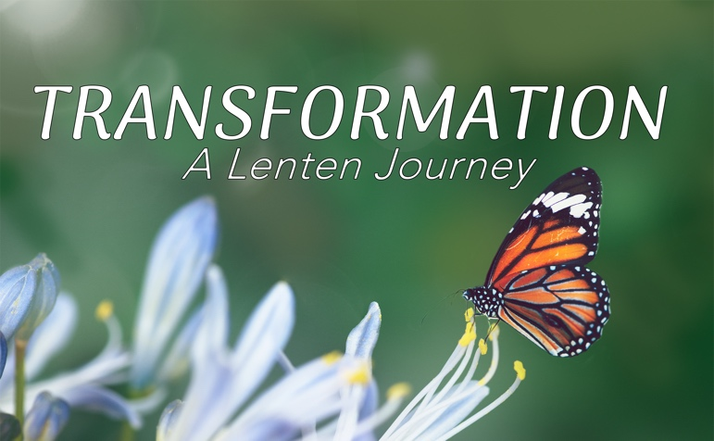

Transformation – A Lenten Journey

Spiritual Practices have been a large part of the Christian faith. These spiritual practices open us up for the Holy Spirit to TRANSFORM our lives. Anything in life calls for some sort of discipline whether in a sport, a job, a relationship, and especially our faith journey. As people of faith, we are called to run the race with endurance. Hebrews 12:1-3 says, “So then, with endurance, let’s also run the race that is laid out in front of us, since we have such a great cloud of witnesses surrounding us. Let’s throw off any extra baggage, get rid of the sin that trips us up, and fix our eyes on Jesus, faith’s pioneer and perfecter. He endured the cross, ignoring the shame, for the sake of the joy that was laid out in front of him, and sat down at the right side of God’s throne. Think about the one who endured such opposition from sinners so that you won’t be discouraged, and you won’t give up.”
During this Lenten season, would you consider the call of Christ to deepen your faith through these spiritual practices? Some of these practices might be new to you and some might be challenging.

SOLITUDE --- March 16th – March 22nd

“There should be at least a room, or some corner where no one will find you and disturb you or notice you. You should be able to untether yourself from the world and set yourself free, loosing all the fine strings and strands of tension that bind you, by sight, by sound, by thought, to the presence of other men. Once you have found such a place, be content with it, and do not be disturbed if a good reason takes you out of it. Love it, and return to it as soon as you can, and do not be too quick to change it for another.” Thomas Merton

March 16th
Scripture: “But Jesus often withdrew to lonely places and prayed.” – Luke 5:16
Reflection: Solitude is a space where we can disconnect from the noise of the world and reconnect with God. Even Jesus took time to retreat and pray alone, showing us that solitude is not about isolation, but about seeking intimacy with God. It’s in these moments of solitude that God speaks to us most clearly, and we find strength for the journey ahead.
Prayer Focus: Reconnecting with God.
March 17th
Scripture: “Be still, and know that I am God.” – Psalm 46:10

Reflection: In solitude, we are invited to be still and embrace the presence of God. The busyness of life often clouds our ability to hear from Him. But when we carve out time to be still, we open ourselves up to transformation. God works in the quiet moments, shaping our hearts and minds to reflect His will more clearly.

Prayer Focus: Pray with our busyness to embrace the presence of God.
March 18th
Scripture: “Jesus, full of the Holy Spirit, left the Jordan and was led by the Spirit into the wilderness, where for forty days he was tempted by the devil.” – Luke 4:1-2
Reflection: Jesus' time in the wilderness was not only a period of solitude but also a time of spiritual preparation. During His time alone, He faced temptation, but He emerged stronger, ready to fulfill His calling. Solitude often leads us into battles, but it also strengthens us for the journey. When we face trials, we can remember that God uses solitude to build spiritual endurance.
Prayer Focus: Pray to make this a season of spiritual preparation.
March 19th
Scripture: “The Lord will fight for you; you need only to be still.” – Exodus 14:14
Reflection: Solitude is a place where we can allow God to fight on our behalf. In the quiet, we relinquish control and trust that God is working in ways we cannot see. He calls us to be still, not to retreat in fear, but to rest in His mighty power. Solitude is not just a time for prayer but also for surrendering our battles to God.
Prayer Focus: Pray surrender all things to God.
March 20th
Scripture: “Search me, O God, and know my heart; test me and know my anxious thoughts.” – Psalm 139:23
Reflection: In solitude, we can allow God to search our hearts and reveal areas in need of transformation. It is a time for honest self-reflection, where we invite the Holy Spirit to convict and purify us. Alone with God, we can confront our weaknesses and receive His grace to grow in holiness.
Prayer Focus: Pray that we take this time to grow in grace and confront our weaknesses.
March 21st
Scripture: “Come to me, all you who are weary and burdened, and I will give you rest.” – Matthew 11:28
Reflection: In the solitude that Christ offers, we find rest for our souls. The constant demands of life can leave us exhausted, but God’s invitation is to rest in Him. Solitude is a divine gift, a moment of quiet where we can release our burdens and be rejuvenated in His presence. It’s not a passive retreat but an active choice to trust in God’s provision for our peace.
Prayer Focus: Pray that we find rest.
March 22nd
Scripture: “Enoch walked faithfully with God; then he was no more, because God took him away.” – Genesis 5:24
Reflection: Enoch’s life is a beautiful example of walking with God in the quiet moments. Solitude is not just about taking time away from others but about walking in step with God, day by day. It’s about developing a continual awareness of His presence, even in the most quiet and ordinary moments. Through consistent solitude, we learn to walk with God in all circumstances.
Prayer Focus: Pray that we have an awareness of God’s presence in your life.

